BRITISH AIRLINE OPERATIONS ANALYTICS REPORT

By Nirosha Jayasundara
Date:16 April 2026

Airline On-Time Performance & Reliability Control Tower
1. Executive Summary
This report presents an analysis of airline operational performance with a focus on departure delays and turnaround reliability. The objective was to identify key delay drivers and develop a control tower framework to support proactive decision making.
The analysis reveals that delays are primarily driven by inbound delay propagation, operational congestion at major airports, and cumulative disruptions throughout the day. Based on these findings, targeted interventions are recommended to improve on time performance and operational efficiency.

2. Business Context & Objective
Airline operations are highly sensitive to disruptions caused by aircraft rotations, airport congestion, weather conditions, and turnaround inefficiencies. Even small delays can propagate across the network, affecting multiple flights.
Objective:
To build an operational control tower that:
- Tracks key reliability KPIs
- Identifies delay drivers
- Enables proactive intervention for at risk flights

3. Data & Methodology
Data Sources
- Flight operations data (schedule vs actual performance)
- Airport performance metrics
- Weather conditions
Approach
- Data cleaning and integration using Python
- KPI definition and calculation
- Exploratory and root cause analysis
- Dashboard development using Power BI

4. Key Performance Indicators (KPIs)
- D15 Rate: Percentage of flights delayed by more than 15 minutes
- Average Departure Delay: Mean delay across all flights
- Delay Propagation Rate: Impact of inbound delays on departures
- Turnaround Overrun Rate: Frequency of extended turnaround durations
- Airport Reliability Index: Composite indicator of operational performance

5. Key Findings
5.1 Inbound Delay Propagation
A strong relationship was observed between inbound delays and departure delays, indicating that disruptions propagate across the flight network.
5.2 Time-of-Day Impact
Delays increase throughout the day, peaking in the afternoon due to accumulated disruptions from earlier operations.
5.3 Airport Congestion
Major hub airports exhibit higher delay levels, reflecting increased traffic volume and operational complexity.
5.4 Turnaround Pressure
Turnaround duration increases later in the day, suggesting operational strain and reduced recovery capacity.
5.5 Weather Impact
Weather variables showed limited direct impact on average delays, likely due to operational adjustments and reduced flight volumes during adverse conditions.

6. Root Cause Analysis
The analysis indicates that delays are not isolated events but are driven by interconnected operational factors:
- Inbound delays cascading across aircraft rotations
- Congestion at high traffic airports
- Limited buffer times in scheduling
- Operational inefficiencies during peak periods

7. Recommended Actions
1. Reduce Delay Propagation
- Improve inbound flight recovery processes
- Introduce buffer times in aircraft scheduling
2. Focus on High-Risk Flights
- Monitor flights with high inbound delays
- Implement proactive intervention strategies
3. Optimize Airport Operations
- Address congestion at major hubs
- Improve ground handling efficiency
4. Adjust Peak Time Operations
- Allocate additional resources during afternoon periods
- Optimize scheduling to reduce accumulation effects

8. Business Impact
Implementation of these recommendations is expected to:
- Improve on-time departure performance
- Reduce delay propagation across the network
- Enhance operational reliability
- Enable data driven decision making

9. Assumptions & Limitations
- The dataset is synthetic and simplified for analysis purposes
- Real world constraints such as crew scheduling and gate availability are not included
- Weather impact is not fully modelled
- Results should be interpreted as directional insights rather than operational decisions

Page 1- Title: Executive Dashboard Overview
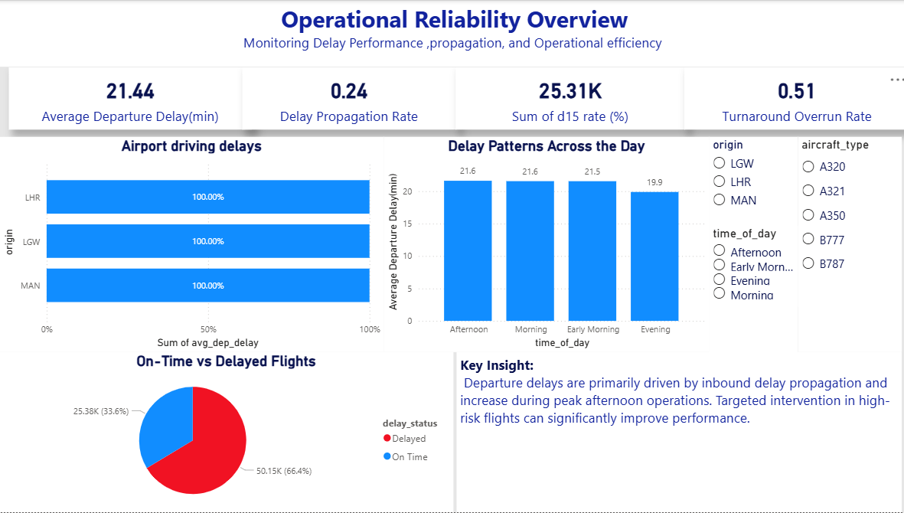
Insight: Average departure delay is ~20 minutes with clear delay propagation, indicating operational inefficiencies.

Page 2: Title: Root Cause Analysis
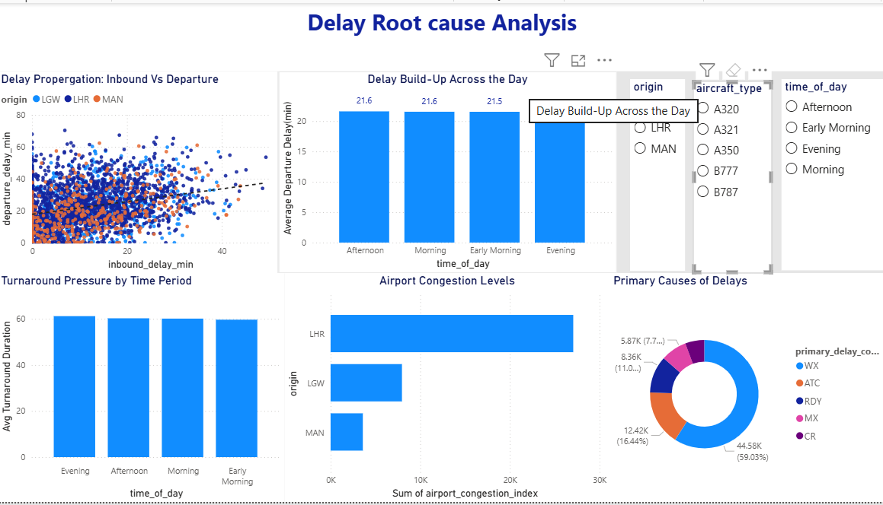
Insight: Strong correlation between inbound and departure delays confirms delay propagation. Airport congestion and turnaround pressure further amplify disruptions.
Page 3: Title: Operational Improvement Plan
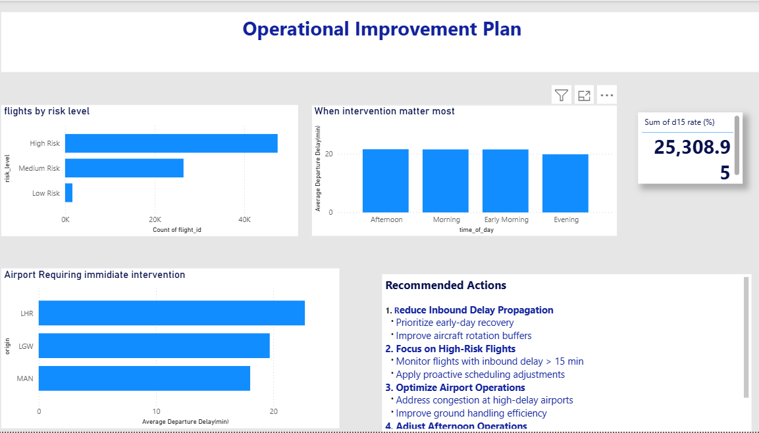
Insight: High-risk flights and peak operational periods require targeted intervention to improve reliability.

10. Conclusion
This project demonstrates how operational data can be transformed into actionable insights through analytics and visualization. The control tower approach provides a scalable framework for monitoring performance and enabling proactive intervention, ultimately improving airline reliability and efficiency.

